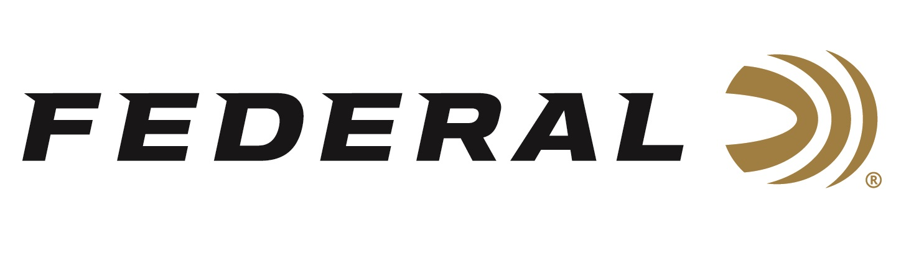

FOR IMMEDIATE RELEASE

**Team Federal’s Vincent Hancock Makes History in Paris**

**ANOKA, Minnesota – August 15, 2024 –** Federal Ammunition congratulates sponsored shooters Vincent Hancock, Austen Smith, Conner Prince, and Derrick Mein on their performances in Paris. Combined, Team Federal won four medals and qualified for the finals in the Men’s Skeet, Women’s Skeet, Mixed Team Skeet, and Men’s Trap events.

“We’re extremely proud that four of our team shooters competed in Paris, bringing home four medals using Federal Gold Medal Paper shotshells,” said Jason Nash, Federal’s VP of Marketing. “The team's extraordinary performance not only captivated the world but also ignited a spark of inspiration. We hope their triumph reverberates through the years, motivating future generations to enjoy and excel in shooting sports.”

In Men’s Skeet, Federal’s Vincent Hancock won gold over USA teammate and sponsored shooter Conner Prince by just one target in a drama-filled finals.  For Hancock, it is his fourth individual gold medal in Men’s Skeet, tying him with legends in Track & Field and Swimming for most gold medals won in an individual event by an American.  Prince, the silver medalist, is coached by and trains with Vincent Hancock, and it was his first time competing at the summer games.

In Women’s Skeet, Austen Smith, also coached by Hancock, claimed a bronze medal in her second appearance on the world’s biggest stage.

Federal’s Derrick Mein finished fifth in the Men’s Trap event.

Finally, to wrap up the shotgun sports, Hancock and Smith teamed up to win a silver medal in the Mixed Team Skeet event.

All the American athletes were shooting Federal’s legendary Gold Medal Paper shotshells manufactured in America by the most skilled American workforce: “It’s a tremendous source of pride for our company and the Federal Ammunition brand,” said Nash.

Shotgunners on Team Federal use Federal Premium Gold Medal, High Over All, and Top Gun shells, which are designed to shoot smoothly and produce dense, uniform shot patterns that turn clay pigeons to dust.

Federal is the number one choice for shotgun shells and manufactures products in America for all competitive and recreational disciplines. See the full lineup, including the latest High Over All, at [www.federalpremium.com](http://www.federalpremium.com).

To support America’s shooting team, visit [www.usashooting.org](http://www.usashooting.org) to find out more.

Federal ammunition can be found at dealers nationwide. For more information on all products from Federal or to shop online, visit [www.federalpremium.com](http://www.federalpremium.com).

**Press Release Contact: JJ Reich**

Senior Manager – Press Relations

E-mail: [Ammunition@tkghunt.com](mailto:Ammunition@tkghunt.com)

**About Federal Ammunition**

Federal, headquartered in Anoka, MN, is an ammunition brand of The Kinetic Group. From humble beginnings nestled among the lakes and woods of Minnesota, Federal Ammunition has evolved into one of the world's largest producers of sporting ammunition. Beginning in 1922, founding president, Charles L. Horn, paved the way for our success. Today, Federal carries on Horn's vision for quality products and service with the next generation of outdoorsmen and women. We maintain our position as experts in the science of ammunition production. Every day we manufacture products to enhance our customers' shooting experience while partnering with the conservation organizations that protect and support our outdoor heritage. We offer thousands of options in our Federal Premium and Federal® lines-it's what makes us the most complete ammunition company in the business and provides our customers with a choice no matter their pursuit.